**RemindMeAhead**

**Project Report**

By –

Adithya S (20BBT0166)

Harsh Gupta (20BCR7143)

Jasjot Singh (20BCE7455)

Muthu Mukilan S (20BDS0094)

# **Introduction:**

## **Overview:**

This project can also be known as an advanced feature of an unbuilt Event reminder app. In this project, we have built an app which will take the users input about any event and will work as a time according to the date mentioned, the best feature included in the app is that it sends SMS about the reminder which usually a person sees due to work reasons. RemindMeAhead App is not just a self-reminder App, but is also used to set remind for your colleagues, parents, friends etc. This App also send SMS to the person you have set reminder for, for examples it can send medicines reminder message to your parents or it can send Birthday wishes to your friend. Even if the user forgets to send a wish to the friend, ReminMeAhead won’t forget to do its job.

## **Purpose:**

How often have you not done things on time – simply because you forgot? Lost count? Well, you’re not alone.

Owing to our busy lifestyle and hectic work-life schedules, we may frequently fail to do things like returning a call or turning up for an appointment with the dentist or completing a deadline on schedule, and so on.

And, the more this happens, the more disorganized your life becomes in addition to the fact that you may also lose a lot of opportunities in your work and life.

Now, simple solutions to this would be asking someone else to remind you, setting a timer or alarm on your phone, or simply noting it down on your calendar.

As easy as this may seem, ask yourself how often you can rely on someone else to remind you about your tasks or how often you’re going to have to take a look at your calendar to keep up with all your appointments or how many alarms could you possibly keep?

It seems unreasonable to do all this when we live in the age of technology where we have everything right at our fingertips!

That’s why we have built RemindMeAhead, which will work as a part of your life where you can do such jobs at your given time but getting a reminder thorugh notification or via SMS.

Since in this world, as well as this nation, we not just take care of ourself but also are supporting hands to our parents and loved ones.

RemindMeAhead helps us to remind our loved ones to follow their schedule too.

# **Literature Survey:**

## **Existing problems:**

Google calendar and reminder are one of the in-built solutions of the reminder Apps problems, but google reminder does only puts notification on the same phone of the user, it can only be used to send our self-reminders.

Problem example –

Suppose a boss has given a week job to its employ or a teacher have given assessments to the students to do every day. In that case, an employee or a student needs to be reminded everyday at a particular time. Earlier there were SMS apps used as reminders but for this, A boss or a teacher himself has to set a reminder to SMS the students or employees every day.

So, Google reminder doesn’t solve this problem an yet it can’t help us to set reminder for someone else. Also, since google reminders works on Google Account, so setting a reminder to your parents, you have to login your account in every device so that they get the notification.

## **Proposed Solution:**

RemindMeAhead is a perfect solution for the above problem situation, if we analyze the above situation then we can suggest a solution.

What if, the boss or the teacher, while announcing or the tasks of the week enters the details of the next day task on RemindMeAhead for their students and employees. And further the RemindMEAhead App send the students and employees an SMS like “TASK-ONE is scheduled for tomorrow; you can finish it by tomorrow 11:59 PM”. You receive this message every day at a particular time like 8PM, wouldn’t it be a great help for the students and employees who are too busy in their projects that they mind forget the important daily routine.

The task becomes very easy if you have someone as a companion who can remind you of your daily important routine and also helps you to maintain your social life where you forget to wish birthdays and anniversaries of your loved one.

RemindMeAhead is the best solution which send SMS with the reminder, not just to the user but also to whosoever and whatever the user wants to remind.

# **Theoretical Analyses and Experimental Investigations:**

## **Block diagram**

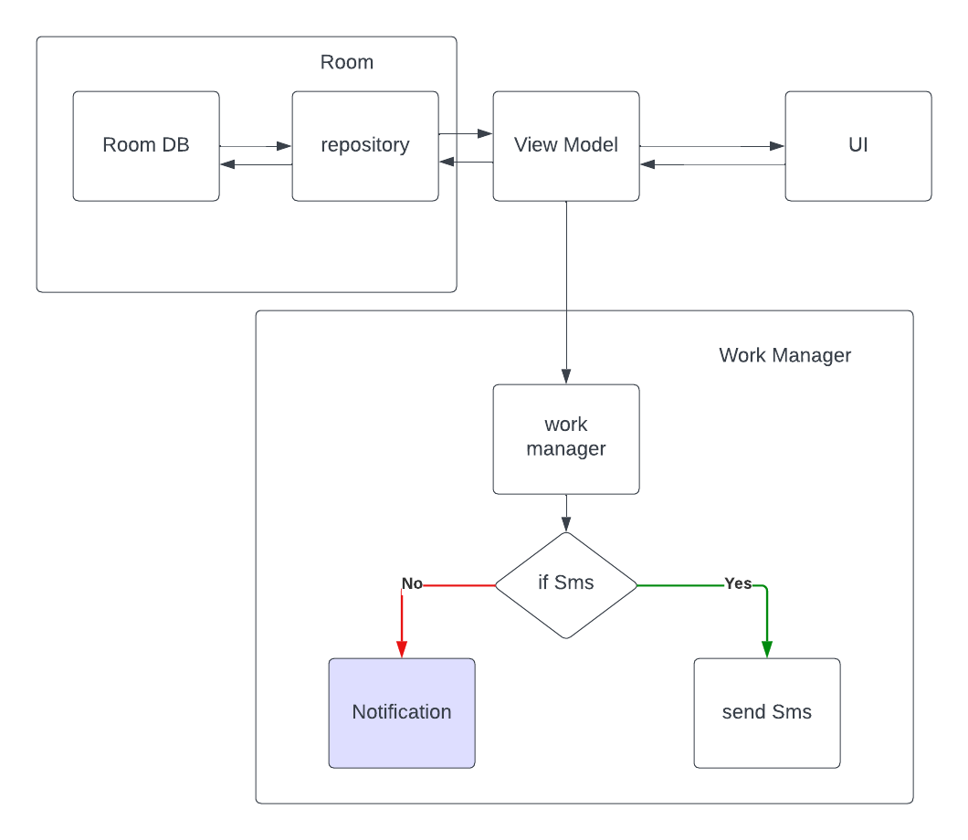

# **Hardware /software design**

The following Screenshots are the architecture of the RemindmeAhead App

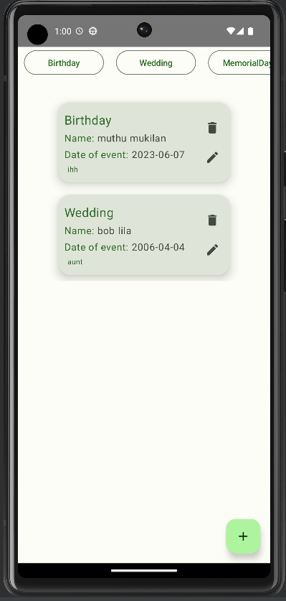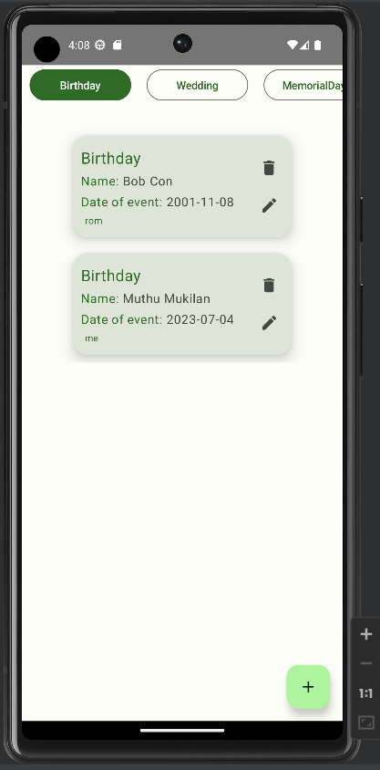

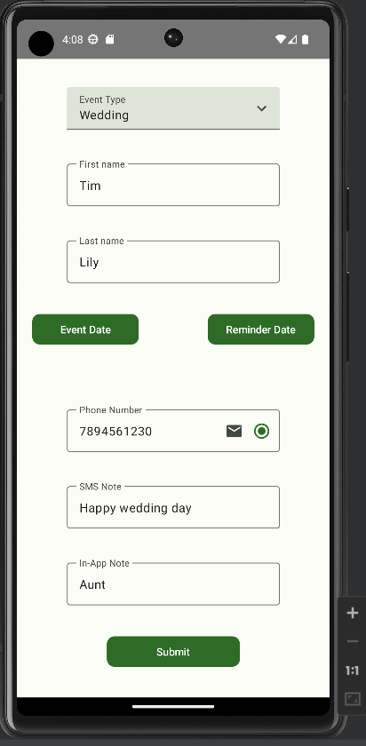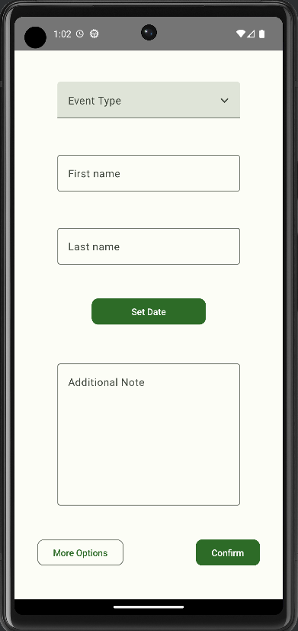

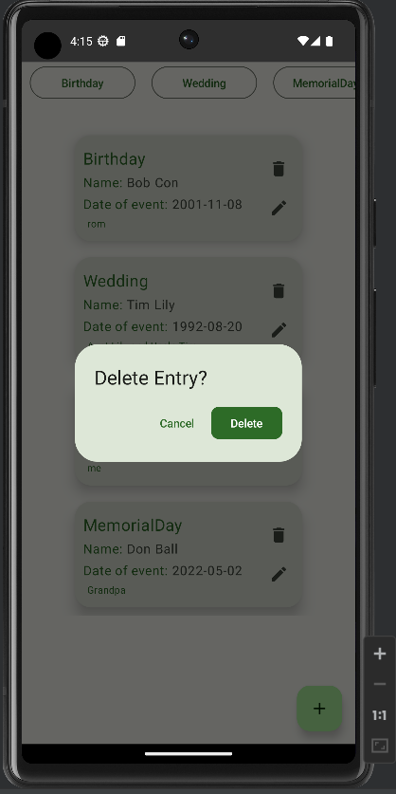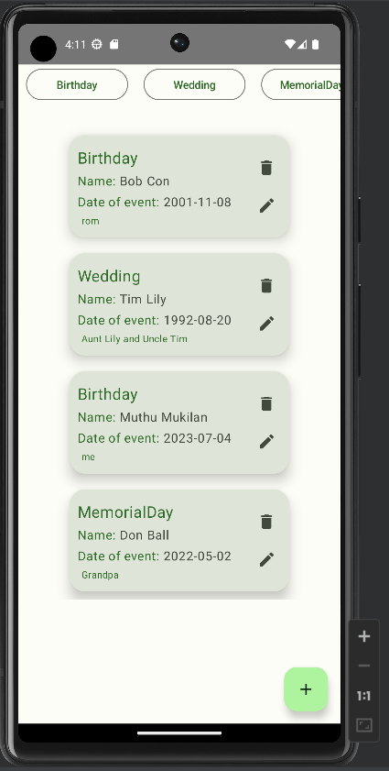

From the above UI Design, it can be noticed that the architecture of the app is done in such a way that the app takes input from the user, user has to enter the phone number with the SMS they want to send, at the entered time, the registered no. will receive the message.

The following things are considered to be used for the App:

Hilt Injection: Hilt is an opinionated dependency injection library for Android that reduces the boilerplate of using manual DI in your project. Doing manual dependency injection requires constructing every class and its dependencies by hand and using containers to reuse and manage dependencies

Room Database: Room is a database layer on top of an SQLite database. Room takes care of mundane tasks that you used to handle with an SQLiteOpenHelper . Room uses the DAO to issue queries to its database. By default, to avoid poor UI performance, Room doesn't allow you to issue queries on the main thread.

Work manager: [Work Manager](https://developer.android.com/reference/androidx/work/WorkManager) is the recommended solution for persistent work. Work is persistent when it remains scheduled through app restarts and system reboots. Because most background processing is best accomplished through persistent work, Work Manager is the primary recommended API for background processing.

# **Flowchart:**

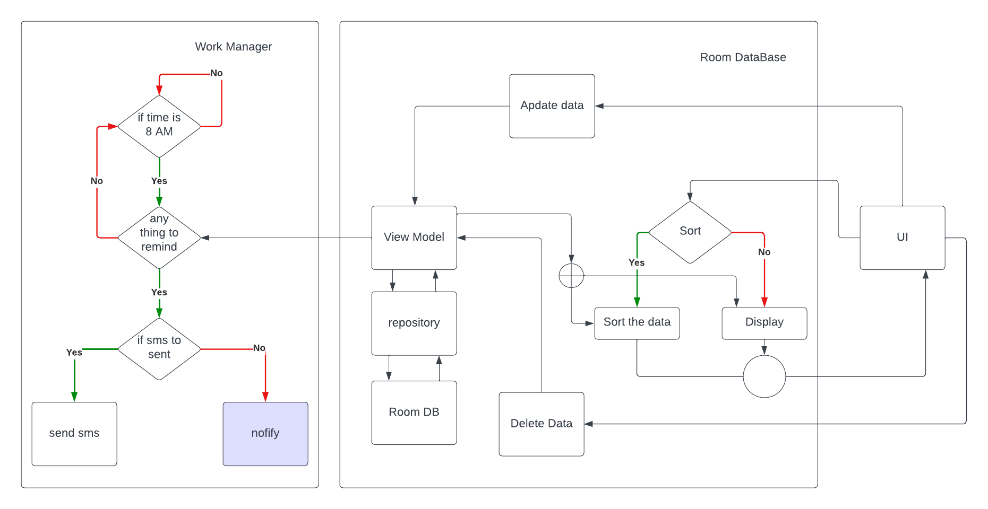

# **Result**

As per all our above experiments and works, it is concluded that RemindMeAhead can be used properly as a Timetable scheduler, not just to get simple reminder alarms or notification, but can work for anyone at anyplace and anytime.

In this world, we Humans as highly developed and skilled living species have grown so much that we target for our living, Human life that started from burning fire, growing plants, hunting to eat and survive, defending ourself from survival has turned into work, education, knowledge, business money, competition, chasing dream and survival with comfort etc. The motive of human beings has changed so much so far. RemindMeAhead is one of the weapons that humans can use in the new era rather than the tools and swords in old age, this weapon is also for survival, our daily tensions, routines, hundreds of tasks and infinite no. of plans needs a manager to collect all the information and remind us on correct day and time.

RemindMeAhead results in relaxation from remembering hundreds of small information at a time, what we have to do is just type the motive, the time, date and the no. of the person you want to remind , Before we even know , the information is shared.

# **Advantages**

* Convenient in Communication: The RemindmeAhead app provides a convenient platform for communication between teachers, students, and parents. It allows instant messaging, announcements to be sent directly to individuals or groups, ensuring timely and efficient communication.
* Real-Time Updates: One of the significant advantages of the Remind app is its ability to provide real-time updates. Teachers can send notifications about class schedules, assignments, and important events, ensuring that students and parents stay informed promptly. This helps in reducing miscommunication and ensures everyone is on the same page.
* Privacy and Security: RemindmeAhead takes privacy and security seriously. The app uses encryption to protect users’ information and communication, providing a safe and secure environment for educational interactions. Users have control over their personal information, and messages are not accessible by others, ensuring a level of privacy for students and parents.
* Easy Organization: Remind provides a easy way to organize and manage the daily routine, even if it’s for us or for our 40 students or hundred employees, it becomes convenient if you can remind other people about the correct info on correct time.

# **Disadvantages**

* Dependency on Technology: Sometimes the technology that is used to relax the human brain for sometime is used in a wrong way , the human gets completely depended on it. Wishes for birthdays and occasions are something which is connect to emotions, setting reminder to wish someone on Diwali breaks the emotions connected to the festival.
* Potential Distractions: While the RemindmeAhead app facilitates communication, it can also become a source of distraction. Receiving notification of something on some wrong may happen.
* Limited Interaction: Although the Remind app enables communication, it may lack the depth and immediacy of face-to-face interactions. Some conversations and reminders require important or intense conversations rather than just a message to be taken place.

# **Applications:**

RemindMeAhead has several applications but few major for maximum usage are that it-

* Can be used in corporate offices which gives tasks and reminders to their employees and interns.
* Can be used in schools and education centers for teachers and administration departments to complete the work.
* Can be used by the government to collect the taxes and dues by the administration and people of the country on time.
* Can be used by wheather departments to remind people about the extrmeties.

# **Conclusion:**

RemindMeAhead is a weapon for this generations which relaxes the human mind to collect every information, to keep accuracy and management in the life, it easy to remember the details, but if we can’t do it, then its RemindMeAhead which be the big support,

Just once mention the work yourself or someone else to do in the week or the month, RemindMeAhead will be the perfect companion.

# **Future Scope:**

RemindMeAhead can be a trustable source to be used by all administration of companies and Education Sectors and Even the State and National governing bodies and agencies.

The source sectors like electricity, income tax, water and other can a major part of the RemindMeApp mission which will assure them the full message encryption as well as the data security.

# **Bibliography:**

Source Code:

<https://github.com/Muthumukilan/RemindMeAhead>

Reference Link:

<https://developer.android.com/topic/libraries/architecture/workmanager>

<https://developer.android.com/training/dependency-injection/hilt-android>

<https://developer.android.com/training/data-storage/room>

<https://developer.android.com/develop/ui/views/notifications/build-notification>

<https://developer.android.com/topic/libraries/architecture/viewmodel>

<https://developer.android.com/guide/navigation>